FULLY WORKED SOLUTIONS
Chapter 15: Seeing the light
Chapter questions
1. λ = v/f = 30/200 = 0.15 m
2. λ = 6 m, f = 1/3 Hz
v = fλ = 6 × 1/3 = 2 m s^{–1}
3. λ = 1.3 m, v = 330 m s^{–1}
f = v/λ = 330/1.3 = 254 Hz
4. n_{X} = 3 × 10⁸/2.1 × 10⁸ =1.43
5. f in window glass = f in air
f = v/λ = 3 × 10⁸/4.20 × 10^{–7} = 7.14 × 10¹⁴ Hz
6. v = c/n_{diamond} = 3 × 10⁸/2.42 = 1.24 × 10⁸ m s^{–1}
7. n_{w} = 1.33, n_{g} = 1.53, θ_{g} = 49°
sin θ_{w} = n_{g} sin θ_{g}/n_{w} = 1.53 × sin 49°/1.33 = 0.87
θ_{w} = 60°
8. sin θ_{w} = n_{a} × sin θ_{a}/n_{w} = 1 × sin 15°/1.33 = 0.195
θ_{w} = 11.2°
9. θ_{a} = 60°, n_{a} = 1, n_{g} = 1.51
sin θ_{g} = n_{a}sin θ_{a}/n_{g} = 1 × sin 60°/1.51 = 0.574
θ_{g} = 35°
x = 4 tan 35° = 2.8 cm

Review questions
9. v = 4 m s^{–1}, f = 10 s^{–1}
$λ=\frac{v}{f}=\frac{4}{\text{10}}=0\text{.}4 m$
10. We can construct the following diagram:
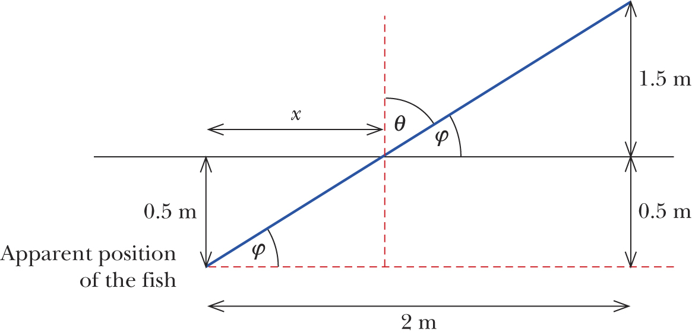
Let x be the horizontal distance of the fish from the normal.
tan φ = $\frac{2}{2}=1$
φ = 45°
x = $\frac{0\text{.}5}{\text{tan} \text{45}°}=0\text{.}5 m$
θ₁ = 90° – 45° = 45°
n₁ = 1, n₂ = 1.33, θ₁ = 45°
n₁ sin θ₁ = n₂ sin θ₂
1 × sin 45° = 1.33 sin θ₂
θ₂ = 32°
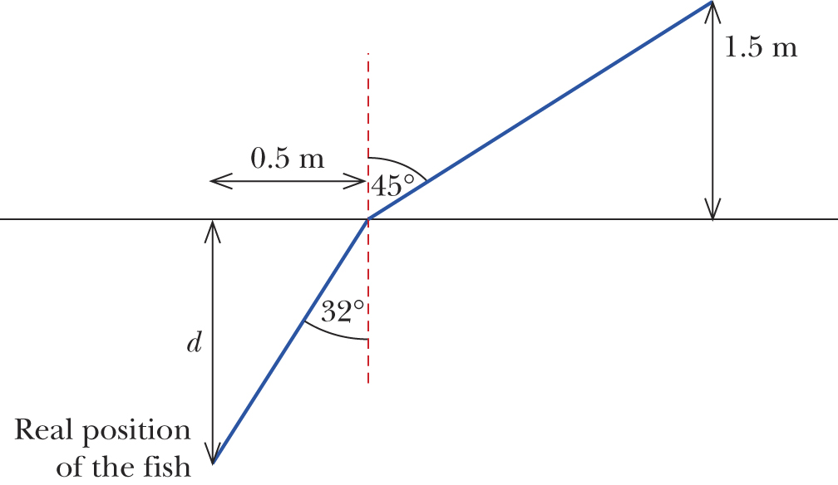
tan 32° = $\frac{0\text{.}5}{d}$
d = $\frac{0\text{.}5}{\text{tan}\text{32}°}$ = 0.8 m
Therefore, the fish is located 0.8 m below the surface of the water.
12. (a) θ₁ = 30°, n₁ = 1, n₂ = 1.33
n₁ sin θ₁ = n₂ sin θ₂
1 × sin 30° = 1.33 × sin θ₂
sin θ₂ = 0.38
θ = 22°
(b) θ₁ = 40°, n₁ = 1, n₂ = 1.33
n₁ sin θ₁ = n₂ sin θ₂
1 × sin 40° = 1.33 × sin θ₂
θ = 29°
Therefore θ₂ is 7° larger.
13. 1 m
14. H I M O T U V W X
15. (a) Plot sin θ₁ on the y-axis and sin θ₂ on the x-axis. The gradient of the line of best fit will be equal to n₂/n₁ or, in this case, n₂.
(b)
θ₁ | θ₂ | sin θ₁ | sin θ₂ | sin θ₁/sin θ₂
0 | 0 | 0 | 0
10 | 6 | 0.174 | 0.105 | 1.6
20 | 12 | 0.342 | 0.208 | 1.6
30 | 18 | 0.5 | 0.309 | 1.6
40 | 24 | 0.643 | 0.407 | 1.6
50 | 29 | 0.766 | 0.485 | 1.6
60 | 33 | 0.866 | 0.545 | 1.6

Therefore n₂ = 1.6.
16.
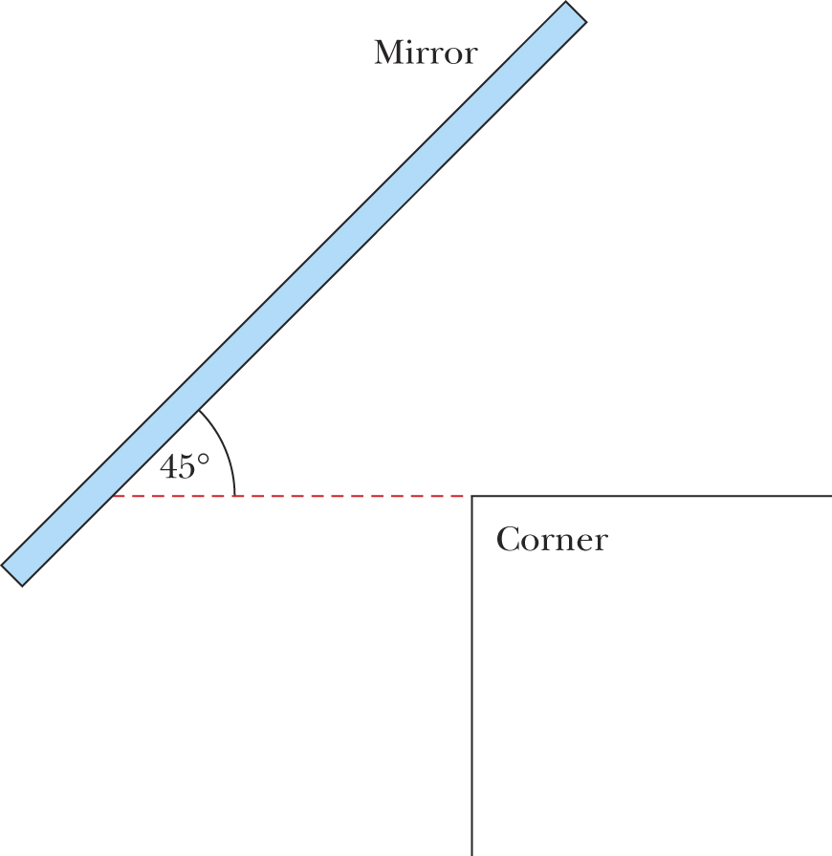
17.
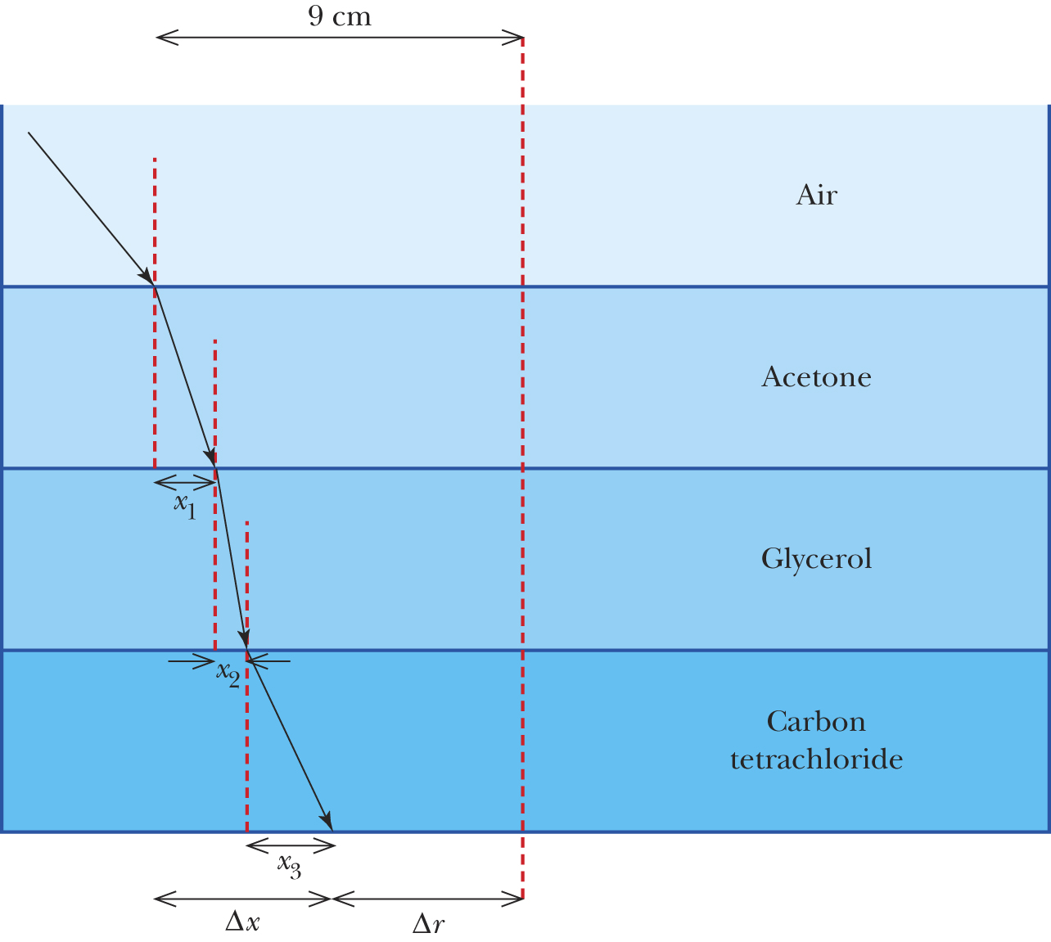
In going from air to the acetone layer:
n_{air} sin θ_{air} = n_{acetone} sin θ_{acetone}
1 × sin 25° = 1.357 × sin θ_{aetone}
sin θ_{aetone} = 0.311
θ_{acetone} = 18.14°
x₁ = 1.5 × tan 18.14° = 0.492 cm

In going from the acetone layer to the glycerol layer:
n_{acetone} sin θ_{acetone} = n_{glycerol} sin θ_{glycerol}
1.357 × sin 18.14° = 1.474 × sin θ_{glyerol}
θ_{glycerol} = 16.6°
x₂ = 1.5 × tan 16.6° = 0.449 cm
In going from the glycerol layer to the carbon tetrachloride layer:
n_{glycerol} sin θ_{glycerol} = n_{carbon tetrachloride} sin θ_{carbon tetrachloride}
1.4746 × sin 16.6° = 1.4601 × sin θ_{carbon tetrachloride}
θ_{carbon tetrachloride} = 16.8°
x₃ = 1.5 × tan 16.8° = 0.452 cm
Δx = x₁ + x₂ + x₃ = 0.492 + 0.449 + 0.452 = 1.4 cm
Δr = 9 cm – 1.4 cm = 7.6 cm.
The ray emerges 7.6 cm from the centre of the beaker.
18.
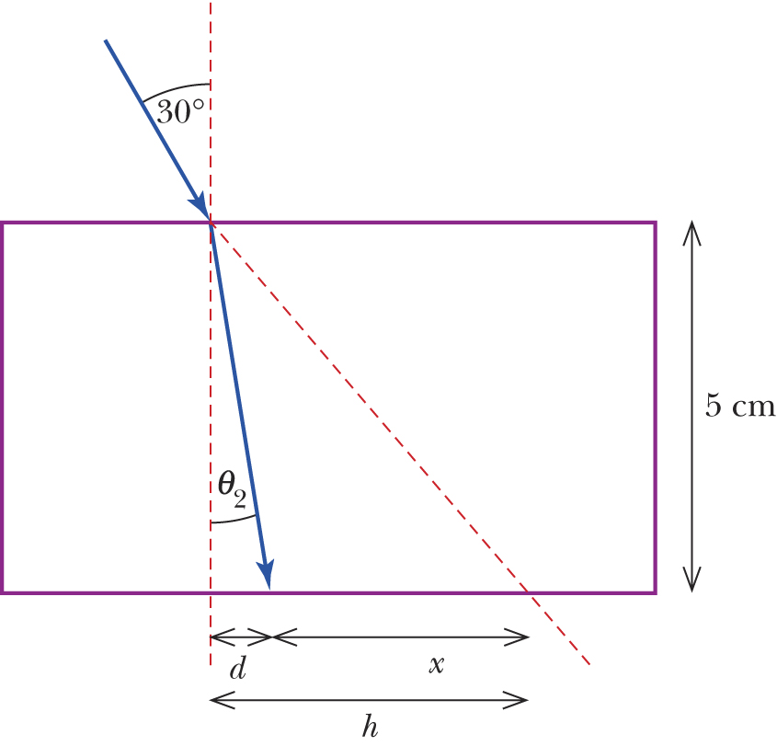
tan 30° = $\frac{h}{5}$
h = 5 tan 30° = 2.88 cm
To determine refracted angle:
1 sin 30° = 1.42 sin θ₂
θ₂ = 20.6°
We can see in the diagram above that:
$$\begin{aligned}\text{tan} \text{20}\text{.}6\text{°=}\frac{d}{5} \\ d=5\text{tan} \text{20}\text{.}6\text{°=}1\text{.}\text{88} \text{cm}\end{aligned}$$
x = h – d = 2.88 – 1.88 = 1 cm
19.
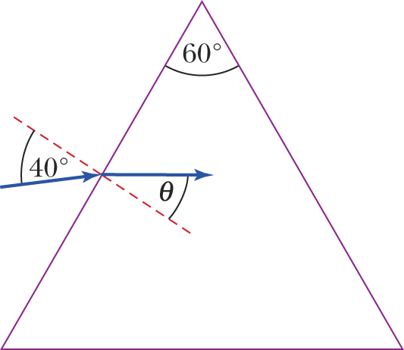
n_{air} sin 40° = n_{glass} sin θ
1 sin 40° = 1.50 sin θ
θ = 25.4°
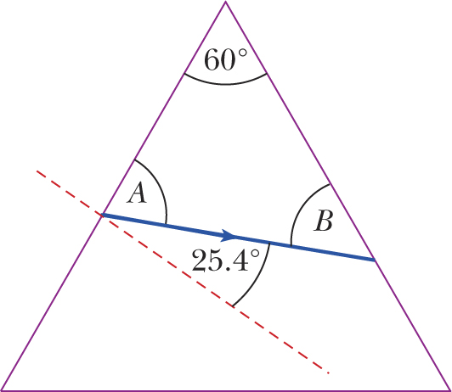
As A + 25.4° = 90°, then A = 64.6°
Also, as 60° + A + B = 180°,
60° + 64.6° + B = 180°
so B = 55.4°
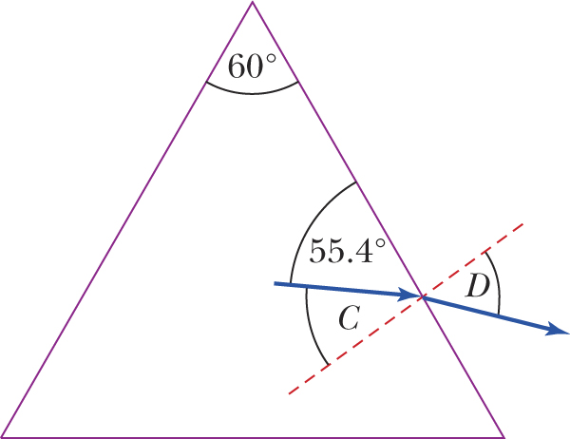
C + 55.4° = 90°, so C = 34.5°
n_{glass} sin C = n_{air} sin D
1.50 sin 34.5° = 1 sin D
0.85 = sin D°
D = 58.2°

